**REG NO:**

**SRM Institute of Science and Technology**



**College of Engineering and Technology**

**School of Computing**

SRM Nagar, Kattankulathur – 603203, Chengalpattu District, Tamilnadu

**Academic Year: 2023-24 (ODD) MCQ**

**Test: CLA-T3** **Date: 09-11-2023**

**Course Code & Title: 18CSE308T -AWS Solution Architect** **Duration:** **20 Minutes**

**Year & Sem: III Year / V Sem** **Max. Marks:** **10**

**Course Articulation Matrix: *(to be placed)***

|  |  |  |  |  |  |  |  |  |  |  |  |  |  |
| --- | --- | --- | --- | --- | --- | --- | --- | --- | --- | --- | --- | --- | --- |
| **S.No.** | **Course Outcome** | **PO1** | **PO2** | **PO3** | **PO4** | **PO5** | **PO6** | **PO7** | **PO8** | **PO9** | **PO10** | **PO11** | **PO12** |
| 1 | **CO1** | 2 |  |  |  | 3 |  |  |  |  |  |  |  |
| 2 | **CO2** | 3 |  |  |  |  |  |  |  |  |  |  |  |
| 3 | **CO3** | 2 |  |  | 3 |  |  |  |  |  |  |  |  |
| 4 | **CO4** |  | 3 |  |  |  |  |  |  |  |  |  |  |
| 5 | **CO5** |  |  |  | 3 |  |  |  |  |  |  |  |  |

|  |  |  |  |  |  |  |
| --- | --- | --- | --- | --- | --- | --- |
| **Part - A**  **(10 x 1 = 10 Marks)**  **Instructions: Answer all** | | | | | | |
| **Q. No** | **Question** | **Marks** | **BL** | **CO** | **PO** | **PI Code** |
| **1** | How does containerization differ from virtualization?  **a) Containers run directly on the host operating system, while virtualization runs on a hypervisor.**  b) Containers are heavier and slower than virtual machines.  c) Containers require more hardware resources than virtual machines.  d) Virtualization provides better isolation than containers. | **1** | **L2** | **4** | **1** | **1.6.1** |
| **2** | What is the primary advantage of using microservices in AWS over a monolithic architecture?  a) Microservices are easier to develop and require fewer developers.  **b) Microservices allow for better scalability, flexibility, and faster development cycles.**  c) Microservices are less expensive to operate in AWS.  d) Microservices provide stronger security compared to monolithic applications. | **1** | **L2** | **4** | **2** | **2.6.3** |
| **3** | What is the main purpose of Amazon Redshift's columnar storage format?  a) To improve data security  b) To enhance data visualization  **c) To optimize query performance**  d) To reduce data storage costs | **1** | **L2** | **4** | **2** | **2.6.3** |
| **4** | In AWS Glue, what is a crawler used for?  a) To create virtual machines in AWS  **b) To automatically discover and catalog metadata about your data sources**  c) To create virtual networks in AWS  d) To schedule ETL jobs | **1** | **L2** | **4** | **2** | **2.6.3** |
| **5** | What is the primary purpose of AWS CloudWatch Alarms?  a) To create virtual machines in AWS  b) To automatically scale AWS resources  **c) To trigger actions based on defined thresholds or patterns in CloudWatch metrics**  d) To generate synthetic data for testing purposes | **1** | **L2** | **4** | **1** | **1.6.1** |
| **6** | How can you use AWS CloudTrail logs?  a) To monitor network traffic  b) To view billing information  **c) To track changes to AWS resources and detect security incidents**  d) To run SQL queries | **1** | **L2** | **5** | **1** | **1.6.1** |
| **7** | What type of information does AWS Config record about your AWS resources?  a) Only metadata like resource names and IDs.  b) Only current resource configurations.  **c) Metadata and current resource configurations, as well as historical configuration changes.**  d) Only historical configuration changes. | **1** | **L2** | **5** | **5** | **5.4.1** |
| **8** | How does AWS Shield Standard differ from AWS Shield Advanced?  a) AWS Shield Standard is free, while AWS Shield Advanced is a paid service.  **b) AWS Shield Standard provides basic DDoS protection, while AWS Shield Advanced offers enhanced protection and 24/7 access to the AWS DDoS Response Team (DRT).**  c) AWS Shield Standard is suitable for on-premises protection, while AWS Shield Advanced is for cloud resources only.  d) AWS Shield Standard includes advanced machine learning algorithms. | **1** | **L2** | **5** | **1** | **1.6.1** |
| **9** | What is a WebACL in AWS WAF?  a) A virtual private network for web applications  b) A web application configuration file  **c) A set of rules that define conditions for allowing or blocking web requests**  d) A web application access control list | **1** | **L2** | **5** | **1** | **1.6.1** |
| **10** | What is a subnet in an Amazon VPC?  a) A public IP address assigned to an instance.  b) A group of EC2 instances in the same availability zone.  **c) A range of IP addresses in your VPC's IP address range.**  d) A public DNS record for an AWS resource. | **1** | **L2** | **5** | **1** | **1.6.1** |

**\*Program Indicators are available separately for Computer Science and Engineering in AICTE examination reforms policy.**

**Course Outcome (CO) and Bloom’s level (BL) Coverage in Questions**

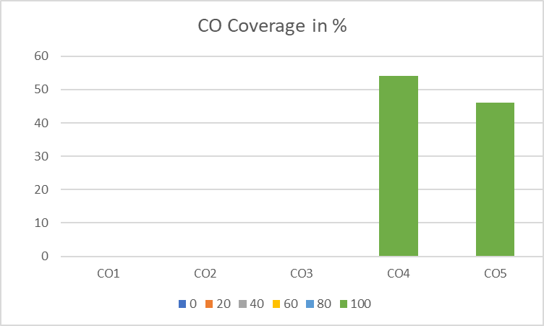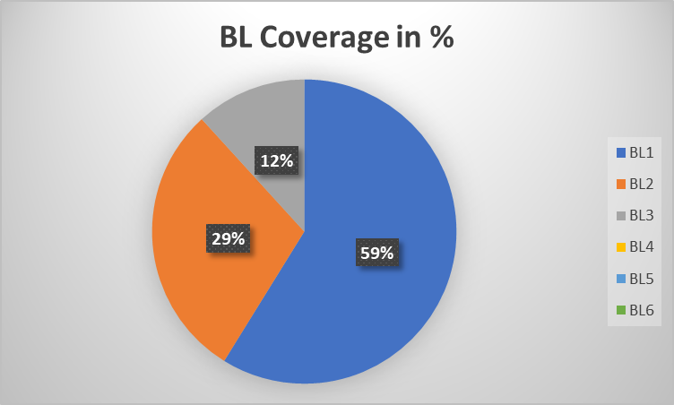

**Approved by the Audit Professor/Course Coordinator**